Dis-Eur-UK-Swanscombe-Mousterian-Cordiform Biface

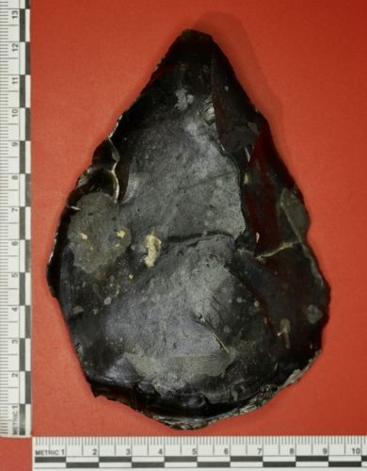 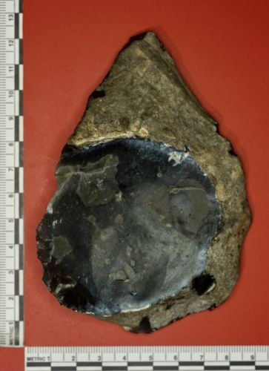 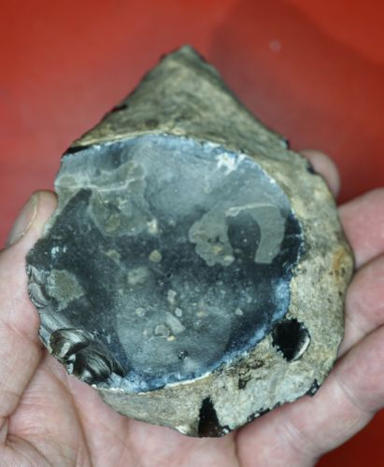 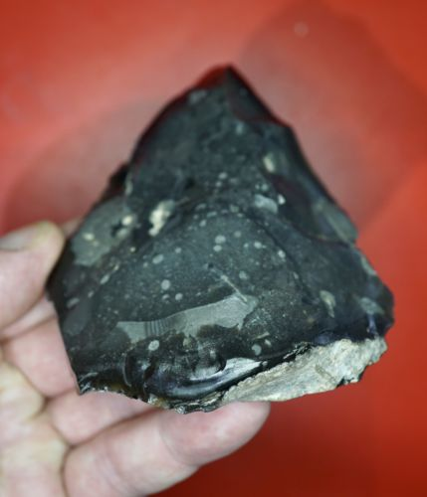 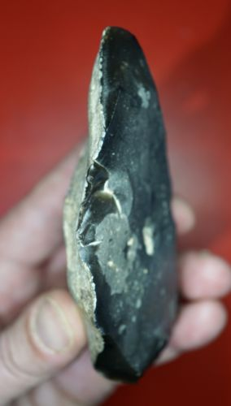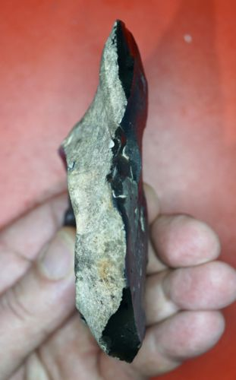

**Formal Label: Mousterian Swanscombe Biface-50,000-40,000 BP**

**Accession Number:**

**LC Classification:**

**Date or Time Horizon:** **50,000-40,000 BP**

**Geographical Area: Northfleet near**  Swanscombe, UK

Map:

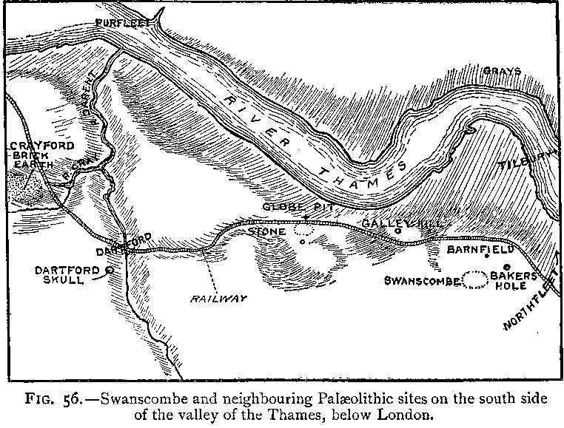

From Keith 1916

**Cultural Affiliation:** Mousterian

**Medium:** Flint

**Dimensions: L** 11.5 cm; W 9 cm (max); T 3 cm.

**Weight:** 232 grams

**Provenance:**

**Condition:**

**Discussion:**

This Neanderthal crafted tool has been made from a black/grey flint flake and is partially bifaced. It is cordiform (heart-shaped) in plan with beautiful symmetry. It has a fine distal point and a rounded bifacially retouched side scraper. Both lateral edges sinuous and are still very sharp.

This is a very rare tool in such good condition from the famous Swanscombe area. It is in museum grade condition. Found in Northfleet, Kent, near Swanscombe, this tool was uncovered in an area that has seen significant commercial, road and rail building work, so it is likely that it was disturbed through construction activity.

The Mousterian period in Europe dated to around 200,000 - 100,000 years ago, it was not until around 100,000 years ago that it made its appearance in Britain, this was probably due to the harsh climate at that time. The Mousterian period in Britain ended circa 40K-35 years ago shortly after the arrival of anatomically modern man, it is thought that there was a period of c 5,000 years where both species lived at the same time and shared ideas.

The Mousterian stone tool industry was based on the production of flakes that were used either as sharp points, side scrapers, notches, denticulated and the thin flat based hand axes. The levallois technique and handaxes continued during the middle Palaeolithic as did the production of various scrapers and bifaces similar to those of the Acheulian tradition.

**References:**

Keith, Arthur. 1915. *The Antiquity of Man*. London.